Toilet Paper Roll Catnip Toy
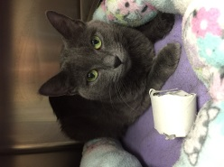
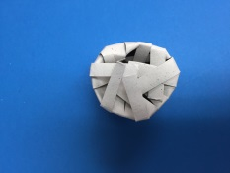
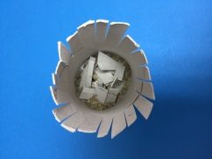
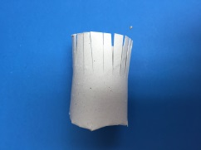
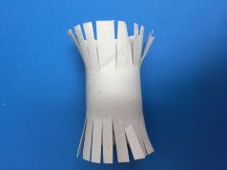

Materials Needed:
- Toilet paper rolls
- Scissors
- Non-Toxic Crayons
- Catnip
Directions:
Step 1: Decorate the toilet paper rolls with non-toxic crayons. Get creative!
Step 2: Fray the ends of the toilet paper rolls with scissors (~3/4”).
Step 3: Bend the frayed ends of one side of the toilet paper roll inward.
Step 4: Sprinkle catnip inside
Step 5: Bend the open ends of the toilet paper roll inward. Catnip will be able to sprinkle out when cats play.

Paper Fans
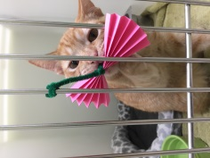
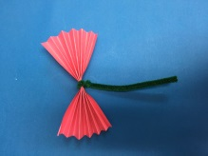
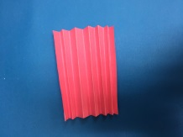
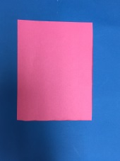
Materials Needed:
- Brightly colored construction paper
- Pipe Cleaners
- Scissors
Directions:
Step 1: Cut sheet of construction paper into fourths
Step 2: Accordion fold the four pieces
Step 3: Wrap pipe cleaner around the middle of the folded paper leaving room for the toy to be hung from a cage.

Toilet Paper Roll Ball
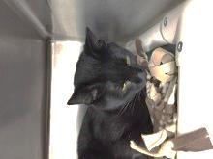
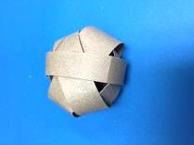
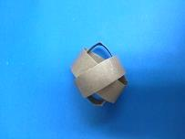
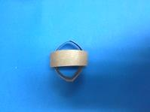
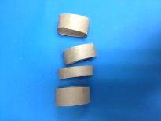
Materials Needed:
- Toilet paper rolls
- Scissors
- Non-toxic Crayons
Directions:
Step 1: Decorate the toilet paper rolls with non-toxic crayons. Get creative!
Step 2: Cut rings from the toilet paper roll (do not have to be uniform!)
Step 3: Insert the first ring into the second ring, then continue with the third and fourth, continue until you have formed a ball.

Feather Toys
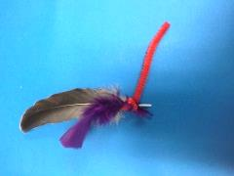
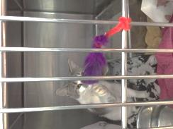
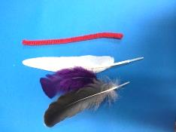

Materials Needed:
- A package of feathers
- Pipe cleaners or yarn
Directions:
Step 1: Select two or three different feathers and bunch them together
Step 2: Wrap one end of a pipe cleaner or tie yarn around the ends of the feathers. Be sure to leave enough pipe cleaner or yarn to be attached to kennel doors.

Tinfoil Balls

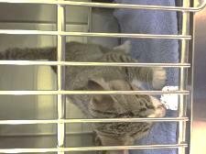
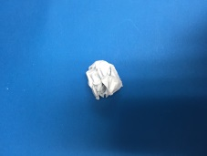

Materials Needed:
- 1 package of aluminum foil
Directions:
Step 1: Crumble a half sheet of tinfoil into a tightly packed ball. Should be approximately the size of a golf ball.

Fleece Knot
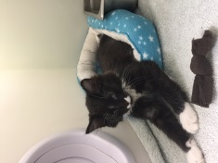
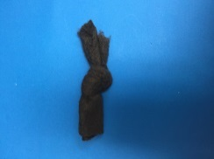
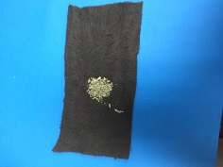

Materials Needed:
- Catnip
- Fleece- can be an old (but clean!) fleece blanket or fleece material can be purchased from craft stores
- Scissors
Directions:
Step 1: Cut fleece into small rectangles (exact size does not matter)
Step 2: Place a small amount of catnip into the center of the rectangle
Step 3: Knot the fleece in the center so the catnip is inside the knot.

Fleece Braid
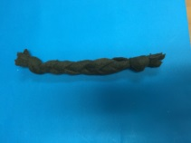
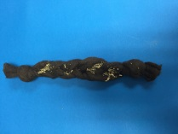
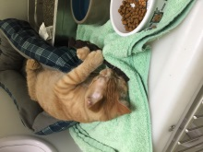
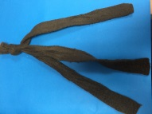

Materials Needed:
- Catnip
- Fleece- can be an old (but clean!) fleece blanket or fleece material can be purchased from craft stores
- Scissors
Directions:
Step 1: Cut out three 8” long strips of fleece- longer, thicker strips can be used to create the same toy for dogs!
Step 2: Braid the three pieces together and knot at each end
Step 3: Stuff catnip between the trips of braided fleece. Catnip is not used for larger dog toys.

Hanging Fleece Toy
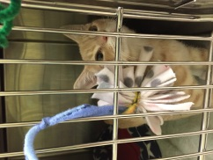
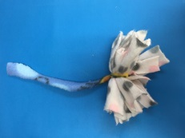
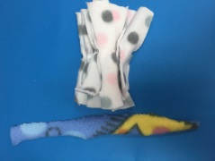
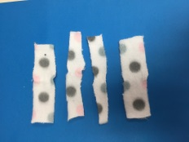

Materials Needed:
- Fleece- can be an old (but clean!) fleece blanket or fleece material can be purchased from craft stores
- Scissors
Directions:
Step 1: Cut strips of fleece 2” long by ½” wide. Approximately 150 strips will be needed
Step 2: Cut longer (6”) strips of fleece. 30 strips will be needed.
Step 3: Bunch several strips (5-6) together and tie in the middle with the longer (6”) strip of fleece

Hanging Yarn Toy
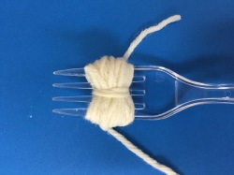
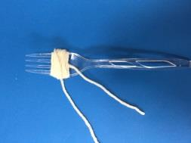
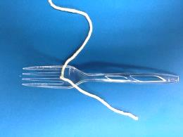
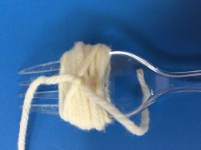
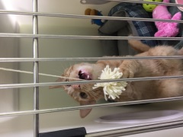
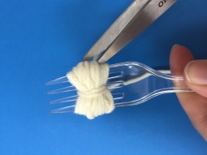
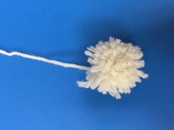
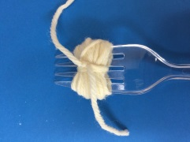

Materials Needed:
- Yarn
- Fork
- Scissors
Directions:
Step 1: String yarn through the center of the fork
Step 2: Wrap longer end of yarn around the fork several times and tie
Step 3: Wrap yarn around center and tie again
Step 4: Cut sides of the yarn to make a pom-pom
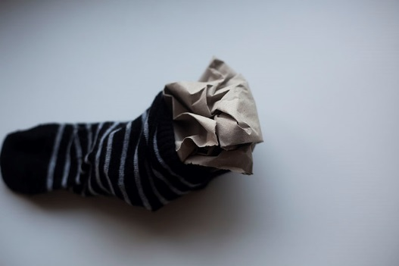
Stuffed Sock Fish
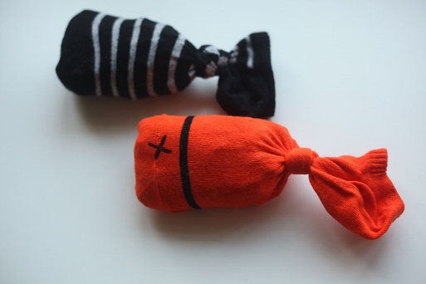
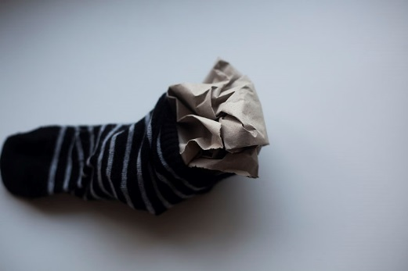

Materials Needed:
- Catnip
- Socks (ankle socks work best!)
- Felt
- Nontoxic fabric glue
- Scissors
- Packing paper
Directions:
Step 1: Stuff sock with crumbled packing paper (the crinklier the better!)
Step 2: Sprinkle a generous amount of catnip in sock, shake to disperse around paper.
Step 3: Knot sock at the base of the stuffed area
Step 4: Cut eyes and mouth out of felt.
Step 5: Attach felt eyes and mouth to sock with nontoxic fabric glue

Reach Box Feeder
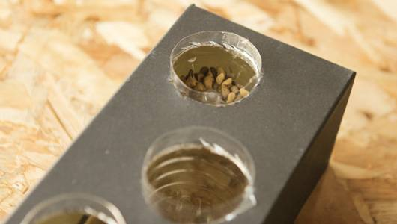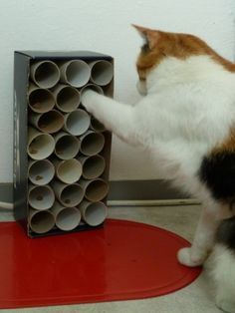
Materials Needed:
- Shoebox
- Three or more plastic water bottles ( 8-24 ounce)
- X-ACTO or utility knife
- Duct tape or nontoxic glue
Directions:
Step 1: Clean and sanitize bottles
Step 2: Cut tops off of the bottles, varying the height before you cut
Step 3: Trace around one of the water bottles on the top of the box. Repeat this step in different locations along the box top, once for each bottle.
Step 4: Cut holes in the box top. It is best if the hole is a bit smaller than the bottle so when the bottle is inserted the bands on the bottle will help hold it in place.
Step 5: Glue or tape bottles in place if they are loose

Water Bottle Crinkle Toy
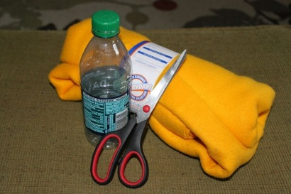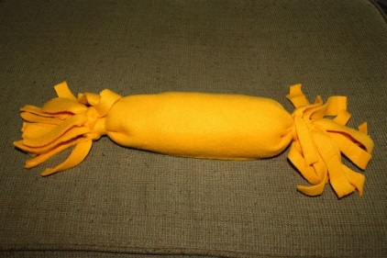
Materials Needed:
- Felt
- Water Bottle
- Scissors
Directions:
Step 1: Remove labels from plastic bottles
Step 2: Thoroughly rinse and clean bottles before use
Step 3: Cut rectangular piece of felt, must be wide enough to wrap around bottle and ~ 3-4” longer than the bottle on each side
Step 4: Roll the bottle inside the rectangular piece of felt
Step 5: Cut two thing strips of felt and use them to tie the ends of the bottle
Step 6: Cut the felt overhanging the bottle into strips

T-Shirt Ball Toy
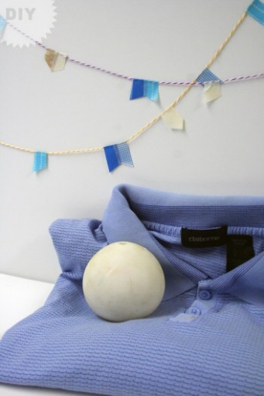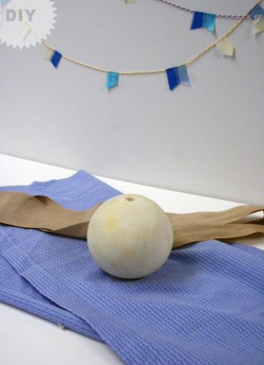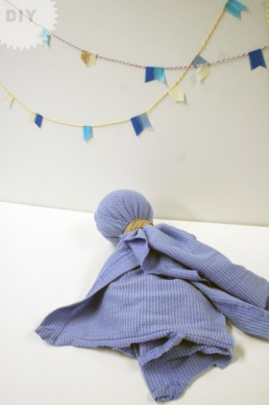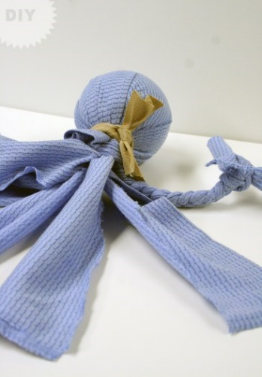
Images provided by: Bark Post
Materials Needed:
- An old t-shirt or polo (~ ½ yards of fabric needed)
- A tennis ball
- A piece of ribbon, a strip of fabric works too
- Scissors
Directions:
Step 1: Cut your shirt (or fabric) into two strips ~6” x 14”
Step 2: Fold fabric strips in half and wrap around the tennis ball (tennis ball should be in the center of folds).
Step 3: Tie ribbon (or fabric strip) around the base of the ball. Make sure the ribbon is tied tight!
Step 4: Cut the tails of your fabric into several strips (~2”)
Step 5: Braid the tails of the fabric together as tightly as possible. Tie several knots at the base of each braid to help keep it together.

Braided T-Shirt Toy
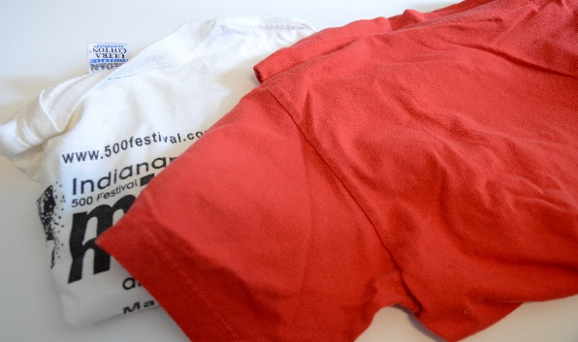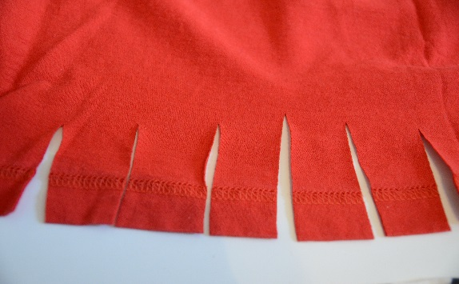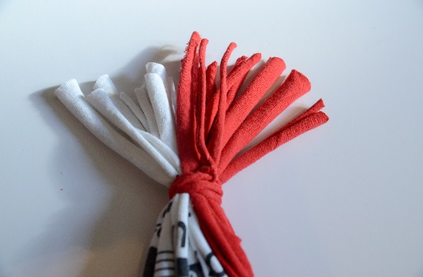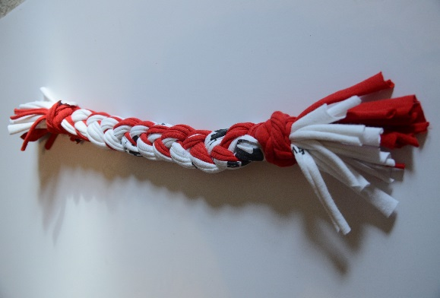
Images provided by Bark Post
Materials Needed:
- 2 gently used t-shirts/ fleece can be used instead
- Scissors
Directions:
Step 1: Cut 2-3” wide slits at the base of both t-shirts
Step 2: After cutting slits rip t-shirts along the slits until you reach the top. Resulting strips should be 18-20” long.
Step 3: Gather t-shirt strips and tie off one end leaving a 2-3” overhang
Step 4: Divide strips into thirds and braid them together
Step 5: Tie up the bottom of the braid leaving 2-3” of overhang

Braided Tennis Ball Tug Toy
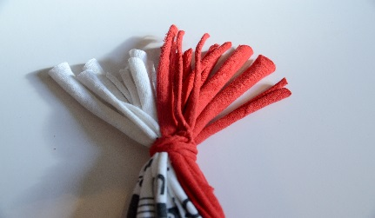
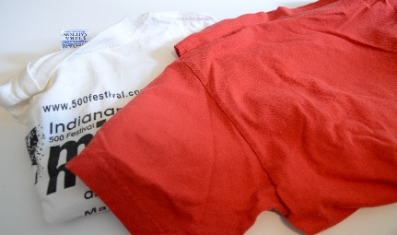
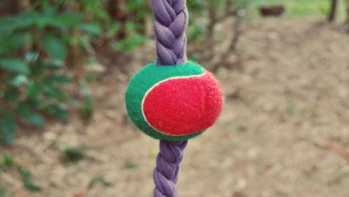
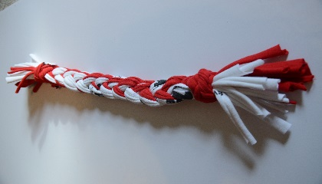
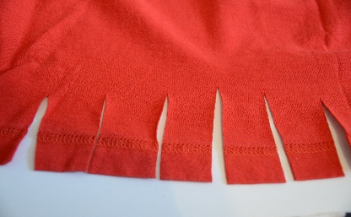

Images provided by Bark Post
Materials Needed:
- 2 gently used t-shirts/ fleece can be used instead
- Scissors
- X Acto knife (optional)
- Tennis ball
Directions:
Step 1: Follow the direction on page 16 to create a braided rope. Do not tie off the bottom of the braid
Step 2: Using the scissors or X ACTO knife and cut a slit (~2”) on two sides of the tennis ball
Step 3: work untied end of the braided rope toy through the tennis ball and slide tennis ball ~ ½ way up the rope
Step 4: Tie off end of rope toy

Denim Chew Toy

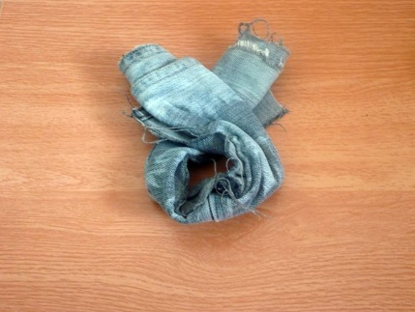
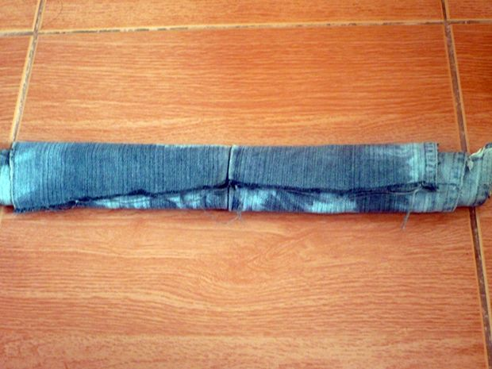
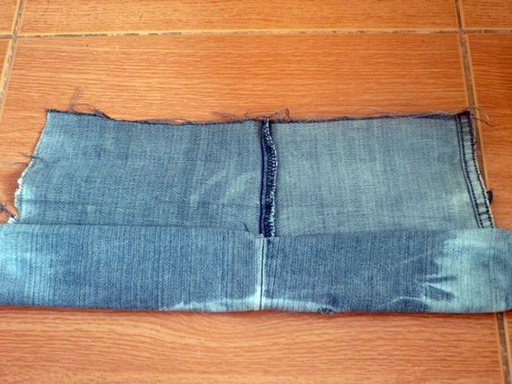
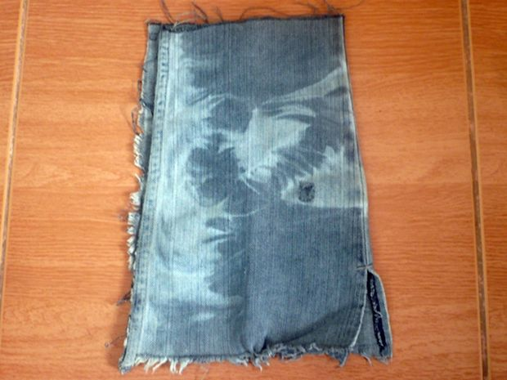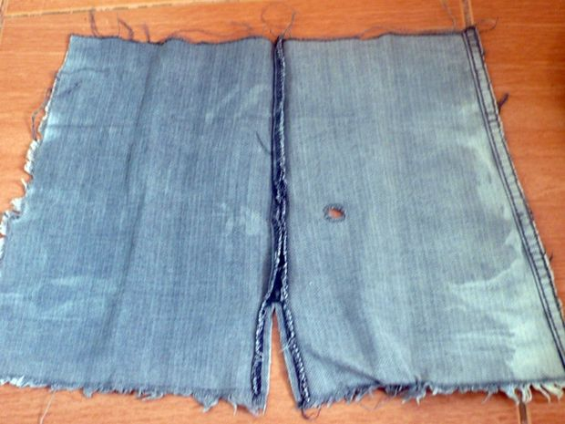

Materials Needed:
- Old jeans
- Scissors
Directions:
Step 1: Cut off the lower part of your jeans (cut at the knee)
Step 2: Cut each leg on one side lengthwise
Step 3: Roll each leg into a tube
Step 4: Make a loop with each tube
Step 5: Close the loop and tie into a knot

